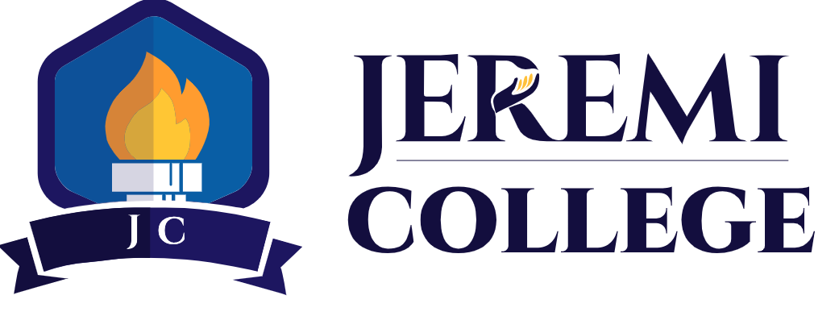

Jeremi College (JC) Tuition Fees and Costs
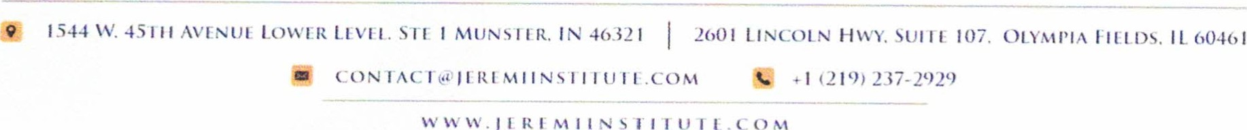
The tuition and fees for attending Jeremi College varies per program. The tuition for the Indiana programs are as follows: The Clinical Medical Assistant cost is $4,980 for the 16-week program (140 hours of instruction and 140 hours of externship). The CompTIA A+ cost is $4,980 for the 12-week program (140 hours). The Phlebotomy Technician cost is $3,650 for the 9-week program (108 hours). The cost for the Computer Support Specialist is $10,000 for the 24-week program (600 hours). The Clinical Medical Assisting Technologist cost for the 24-week program is $12,000 (600 hours). The tuition for the Illinois programs are as follows: The Clinical Medical Assistant cost is $4,800 for the 16-week program (140 hours of instruction and 140 hours of externship). The CompTIA A+ cost is $4,800 for the 12-week program (140 hours). Tuition includes all books, National certification exams and laptops/Chromebooks. All students are given books and a laptop/Chromebook to use for the completion of their program.

